Hi Sunny –

For this next project, I would like to build a sync between my TD Ameritrade account and Collective2. The goal will be to have a designated strategy on Collective2 directly mirror the positions currently held in my TDA account.

Fortunately, Collective2 has an API function that makes all the logic easy once the positions are fetched from TDA: <https://collective2.com/api-docs/latest#setDesiredPositions>

Collective2 will do all the heavy lifting of any position resizing, open or closing of positions, etc. All that needs to happen, is a list of lists needs to be sent to the endpoint containing all the desired positions.

The most amount of work that needs to be done is using the TD Ameritrade API to read the current positions held in the brokerage account. This would theoretically apply to any stock, option and/or futures positions held. While also being mindful if the positions are either long or short.

The trickiest of these may be the options symbols. Collective2 has a specific format to adhere to so that their api will understand which symbol, strike and expiration an option symbol is attributable to. The specifications can be found here: <https://www.collective2.com/options>  
**I have included dictionaries at the bottom of the C2_CRUD_.py file that may be helpful. They are commented out for the time being but I left them just in case.

I have put together a class with a few functions that I have used over time to update portfolios on Collective2. Please see the screenshot below of the first lines from the file:

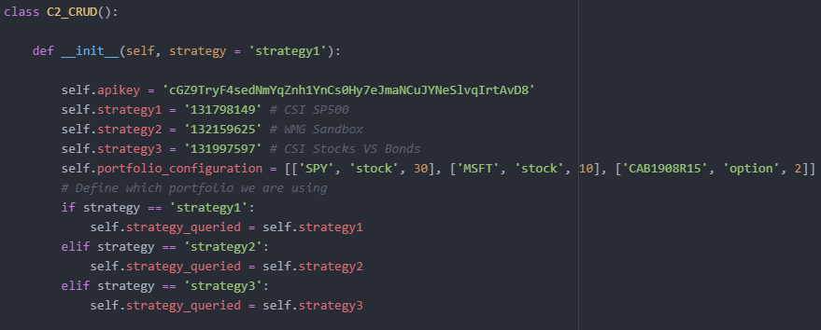

The class contains a list variable named “self.portfolio_configuration” that contains the portfolio payload that can then be given to Collective2 using the configure_portfolio() function. After sending this list of lists to the Collective2 API, the rest happens automatically on their servers. So the key will be to have a function (or series of functions), that reads TDA and pulls down the current list of positions in the brokerage account, and edits this list of list to contain the exact positions reflected in the portfolio… then it can be sent to Collective2 using the existing functions. I think it will be easiest to just build the functionality into the existing python file containing the C2_CRUD class, but up to you.

The first list [‘SPY’, ‘stock’, 30] would mean 30 shares of SPY stock. If the integer were instead -30, a short position would be opened.

Feel free to play around all you want with either of the three strategies that have strategy IDs (self.strategy1, self.strategy2, self.strategy3). I’m not using any of them right now, so no worries to open or close positions in them. Unfortunately, any trades sent will not reflect until the market opens which may make testing a bit tricky. But either way, don’t worry about opening/closing potentially an unlimited amount of positions.